EE5356 LAB Assignment #3B

The test image, Girl256color.raw.

1) From project #3, use the RGB color components to obtain Y,I,Q.

Y: luminance, I: hue, Q: saturation

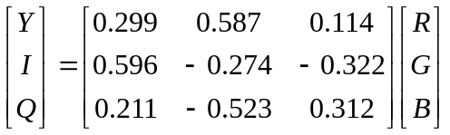

Show the luminance Y and chrominance I and Q components.

2) Use the matrix transformation

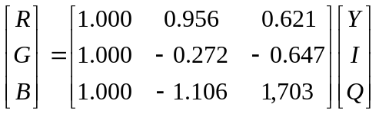

Show the R,G,B components.

See ‘Color Space and Residual Color Transform Support’ section in the paper G. Sullivan, P. Topiwala and A.Luthra “The H.264/AVC Advanced Video Coding Standard: Overview and Introduction to the Fidelity Range Extensions”, SPIE Conference on Applications of Digital Image Processing XXVII Special Session on Advances in the New Emerging Standard:H.264/AVC, vol. 5558, pp.53-74, Aug. 2004.

3) Perform color space conversion from R,G, B to Y,Cg,Co given flowers.bmp (500x362) on the course website (Cg = Green Chroma, Co=Orange Chroma)

Show the images as Y,Cg,Co components

4) Perform the inverse color space conversion from Y,Cg,Co to R,G,B

Show the images as R,G,B components

Note:

-Experimental Procedure
RGB
(500x362)
Color space conversion
Y,Cg,Co
(500x362)
Inverse
color space conversion
Original
color image
Decompose
Compose

(500x362)
Reconstructed color image

-Flowers.bmp image

362
500

R,G,B

In this paper a new color space called Y,Cg,Co is suggested as part of the H.264 AVC (advanced video coding) standard.

- A new color space is defined by using the following basic equations:

Y=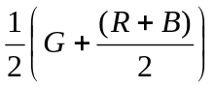; Cg=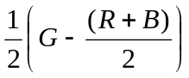; Co=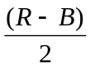
or not to introduce conversion rounding error by using the following equations:

Co=R-B; t=B+(Co>>1); Cg=G-t; Y=t+(Cg>>1) for the forward transformation
and t=Y-(Cg>>1); G=t+Cg; B=t-(Co>>1); R=B+Co for the inverse transformation

where t is an temporary variable and “>>” denotes an arithmetic right shift operation
References:

- S.K. Kwon, A. Tamhankar and K.R. Rao “Overview of H.264 / MPEG-4 Part 10” JVCIR, vol. 17, pp. , 2006, Special Issue on "Emerging H.264/AVC Video Coding Standard," – Available on line at www.sciencedirect.com, (go to : Articles in Press, JVCIR : Journal of Visual Communication and Image Representation ).

- G. Sullivan and T. Wiegand, “Video compression – from concepts to H.264/AVC standard”, Proc. IEEE, vol.93, pp.18-31, Jan. 2005.

- Y. Su, M-T Sun and K-W. Lin, “ Encoder optimization for H.264/AVC fidelity range extensions “, SPIE/VCIP2005, vol.5960, pp.2067-2075, Beijing, China, July 2005.

- G.J. Sullivan, “ The H.264/MPEG-4 AVC video coding standard and its deployment status”, SPIE/VCIP 2005, Vol. 5960, pp. 709-719, Beijing, China, July 2005.

- S-H Wang et al, “ A software-hardware co-implementation of MPEG-4 advanced video coding (AVC) decoder with block level piping”, The Journal of VLSI Signal Processing Systems, vol. 41, pp. 93-110, Aug. 2005.

- D. Marpe, T. Wiegand and S. Gordon, “ H.264/MPEG-4 AVC fidelity range extensions; tools, profiles, performance and application areas”, IEEE ICIP 2005, vol. 1, pp.593-596, Genova, Italy, Sept. 2005.

- Y-K. Chen et al, “ Implementation of H.264 encoder and decoder on personal computers”, J. VCIR, pp. , vol.17, 2006.

- T-M. Liu et al, “An 865-μW H.264/AVC Video Decoder for Mobile Applications”, IEEE A-SSCC, pp. ,Hsinchu, Taiwan, Nov. 2005

